~50 subject in each condition: backward (b), forward (f), ~90 subject in random/control (r)

- Average for each participant separated by correct rejection and hits

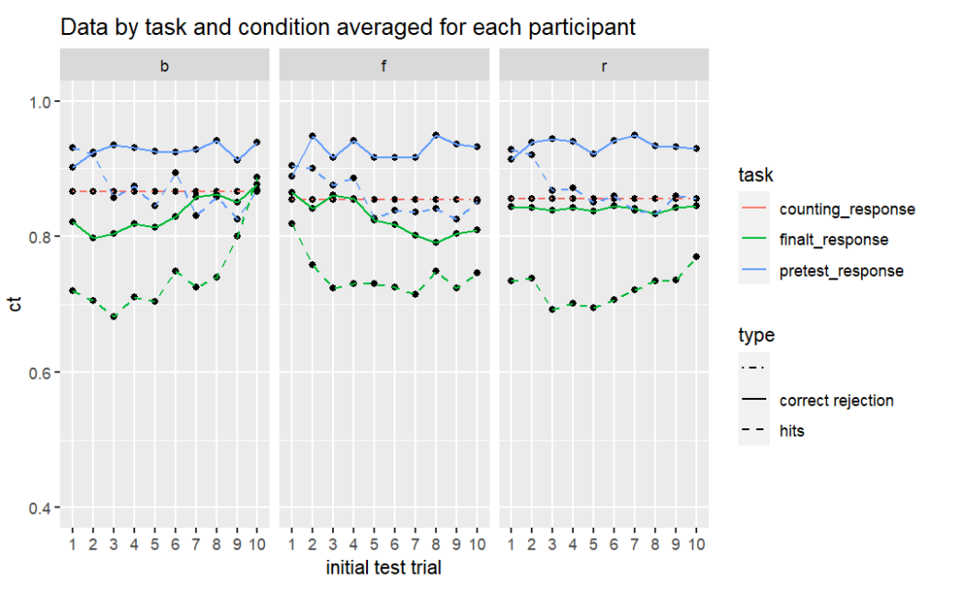

- Average probability of correct separated by probetype
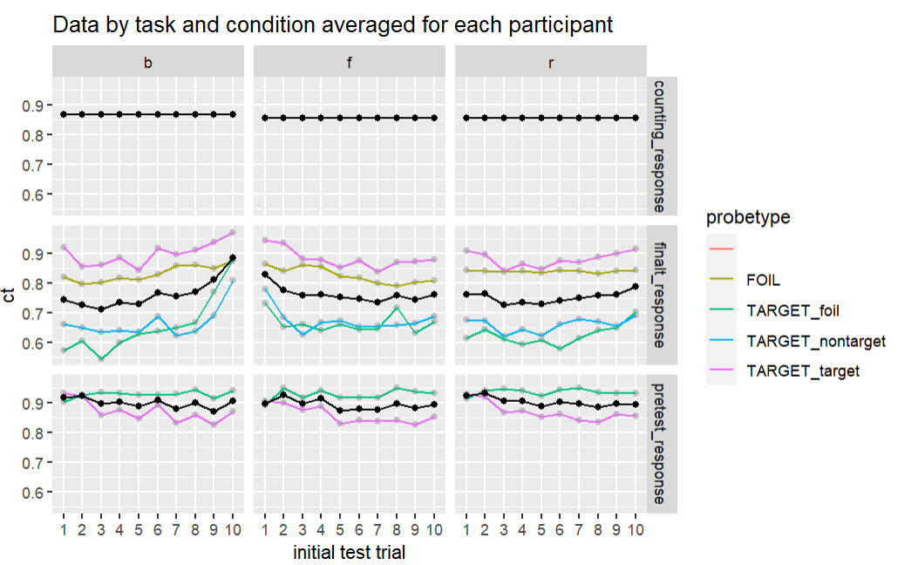

- 3 condition’s Performance of final test by final test position
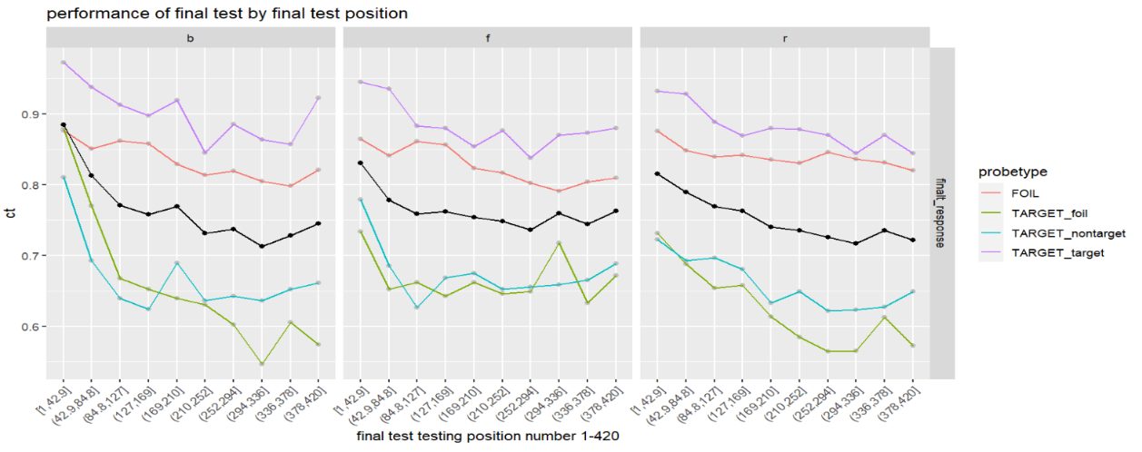

- Conditional probability correct of post test based on pretest response
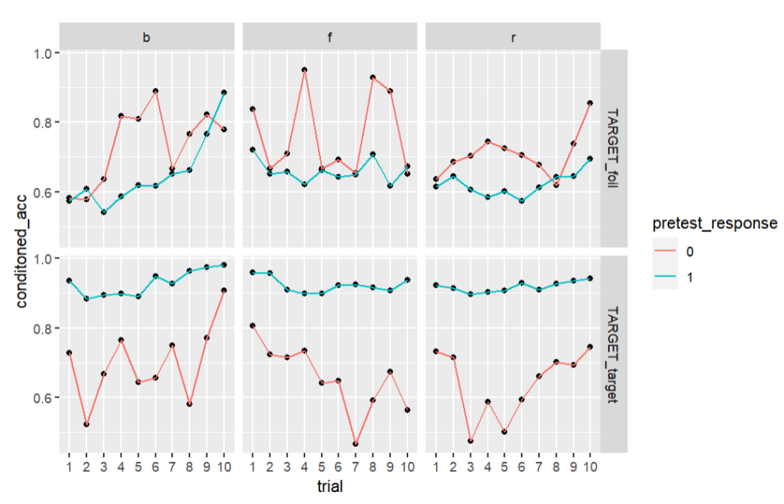

- Serial position curve of post test by initial test & study position

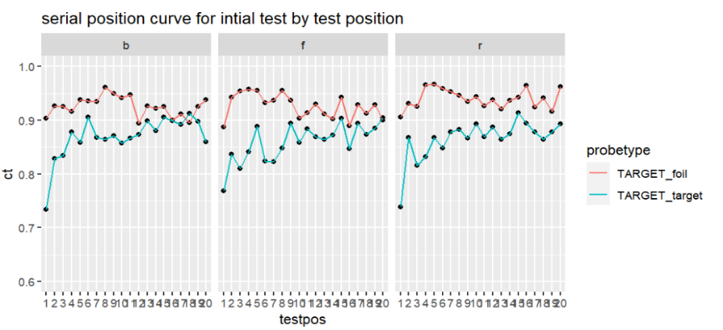
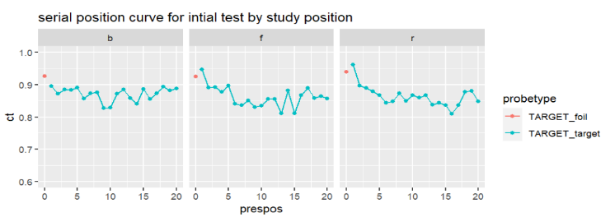

See next page

